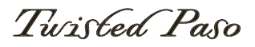

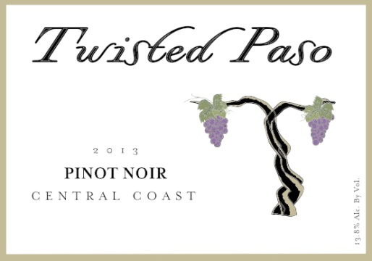
Variety: Pinot Noir
Vintage: 2013
Appellation: Central Coast

Tasting Notes
The delicate red hues in the glass give this wine the distinctive Pinot Noir appearance. Dark cherry, ripe strawberry and floral scents fill the glass. The initial mouth feel is bursting with raspberry, strawberry and hints of citrus. The spicy tannins from the whole cluster fermentation reveal themselves in the mid palate and produce a wonderfully long finish for a Pinot Noir.

Growing Season
2013 was basically a perfect vintage for much of California, and especially for the Central Coast. The mild but long growing season allowed for a fantastic expression of Pinot Noir. This delicate varietal thrives when conditions are less extreme, allowing for gradual ripening and flavor development.

Vineyards
The Pinot Noir for 2013 came from the Scheid Vineyards in the Monterrey County. The western edge of the Salinas valley on the foothills of the Santa Lucia Mountains has become one of California’s premier locations for the production of Pinot Noir.

Winemaker Notes
The 2013 vintage developed in such a way as to allow us to try something new here at Calcareous, whole cluster fermentation. About 30% of the harvest was added to the fermentation tanks still on the stem and mixed in with de-stemmed fruit. The addition of the uncrushed fruit still on the stem added beautiful spice, tannin structure, and slowed the fermentation. With the yeast having to ferment from within the unbroken skin of the grape, the lack of abundant oxygen promotes a gradual fermentation, allowing a long 26 days on skin to extract a maximum amount of skin components without being heavy handed. The lots were gently pressed and aged in 35% new French oak and 65% neutral French Oak for 14 months. This whole process produced a Pinot Noir of amazing density and full flavored profile.

Technical Notes
Alcohol: 13.8% Brix: 24.5 pH: 3.54 TA: 6.7g/L

